Gathering Data

**Discussion**

Unstructured data is very hard to work with and many times impractical. Imagine a bunch of post-it notes stuck to your desk each telling you a different assignment and due date for school assignments. It would be nice to order and structure this data so that you could prioritize each assignment. One way to structure data is to store it in a table using rows and columns.

**Class Exercise**

Answer the following questions based on the table shown.

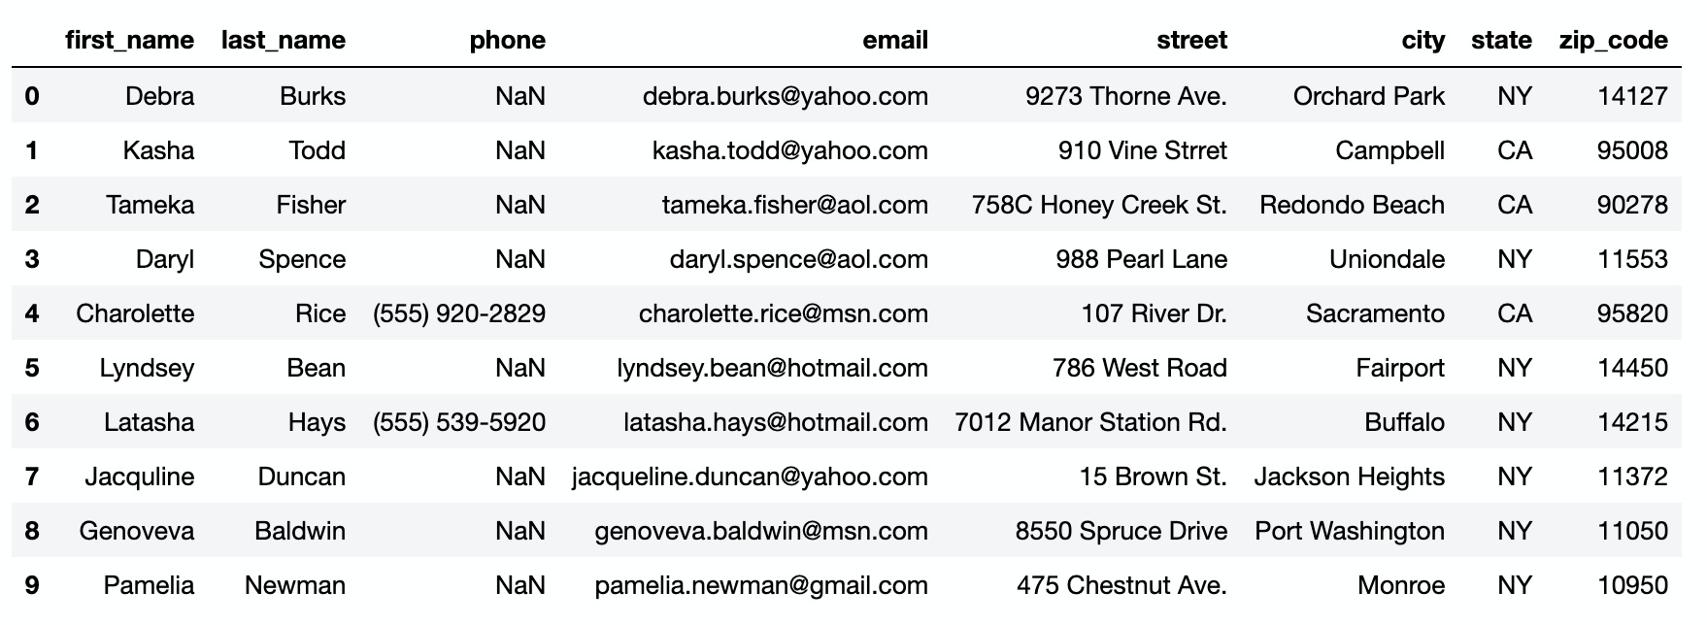

1. How many rows of data are there? How many columns?
2. What might be a good name/title for this table?
3. What is listed in the 4th row, 3rd column?
4. What is listed in the 9th row, 2nd column?
5. What do you suppose NaN might mean?

Create a table for the following unstructured data.



1. Why did you choose the columns (variables) that you did?
2. How could you sort the data to help you prioritize your tasks?

Research or find the nutrition facts labels for 3 foods or drinks that you regularly consume. Use the information to create a table of usable rows and columns.

1. Which columns in your table include quantitative data (if any)?
2. How could you collect or include more qualitative data?
3. Formulate at least TWO statistical questions that you could use this data to answer.